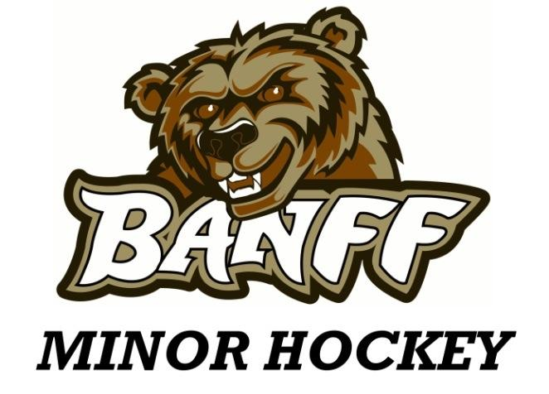

Coach and Manager Application Form

Thank-you for your interest in volunteering your time to coach our players. Without you, our club would not run. Taking on a coaching position requires a varied commitment to two weekly practices and weekly games (which may include travel as far as Airdrie) from September through to the end of March. Different coaching positions hold different time commitments - please ensure you are realistic with your schedule!

How do we support coaches?
- Reimbursement of Respect in Sport for Activity Leaders fee, once successfully completed
- Reimbursement of certification fees for required coaching courses, once successfully completed
- Previous coaches available to mentor as needed
- Online free access to coaching warm-ups and drills through Ice Hockey Systems
- 50% off the purchase price of BMH coach jacket, if available
- An executive board to support you with any other needs

Personal Information
Full name:
Hockey Canada ID number:
Birthdate:
Physical and mailing address:
Phone number(s):
Email:
Do you have a child playing for Banff Minor Hockey? Yes/No

Qualifications – please check all that you have obtained
- Respect in Sport Activity Leaders
- Coach 1
- Coach 2
- Checking skills
- Other (course names may have changed since you originally took them. Please refer to your Hockey Canada account):

Experience – Please list previous experience relevant to coaching hockey, starting with the most recent. Include age group, year, association and team name.

Positions
Please check the position(s) you are interested in applying for. Refer to the position descriptions at the end of this document to understand the responsibility of each role. If you check more than one, please indicate your 1st and 2nd choice.
- Head coach
- Assistant coach
- On ice assistant
- Team manager

What level of hockey are you wanting to coach/manage?
- U7 (ages 5/6)
- U9 (ages 7/8)
- U11 (ages 9/10)
- U13 (ages 11/12)
- U15 (ages 13/14)
- Pond (ages 9-12)
- Goalie development – various ages
Are you already qualified to coach the level you chose above, or do you require additional certification?
Qualified: __________ Require courses: ___________

What are your personal goals as a coach for minor hockey?

A current criminal record vulnerable sector check must be included with this application. This can be processed at our local RCMP station for free provided you bring in the attached form to their office.
Please submit this application completed form, along with your RCMP check to registrar@banffminorhockey.com or in person to any board member. In addition to this application, BMH may request an interview with applicants.
Undertakings:
- I hereby consent to the disclosure of the above information.
- I hereby acknowledge the authority of Banff Minor Hockey, Hockey Alberta, and all relevant leagues and agree to carry out and abide by their constitutions, bylaws, rules, regulations and policies (and to ensure I am aware of these policies).
- I hereby agree to familiarize myself with the National Coaching Certification Program (NCCP) requirements for coaching minor hockey and ensure that I maintain the required level of certification.
- Attached is a copy of my criminal record vulnerable sector check.
Signature:

Name (printed):

Date:

Thank-you!

Descriptions of Roles

Head coach
- Serve as the official spokesperson on behalf of the team
- Coordinate the delegation of responsibilities to the assistant coach and manager
- Plan on and off-ice activities in consultation with the assistant coach
- Organize parents meeting to inform them on the team's hockey season plan
- Coordinate player evaluation and selection in conjunction with other coaching staff
- Plan, implement and control pre-game preparation and communication with the team
- Design the practice plans in consultation with the assistant coach
- Coach the team in all games and practices, if possible
- Establish rules for the team and oversee the supervision of the players

Assistant Coach
- Assist with player evaluation and the player selection process
- Assist with planning, organizing and conducting practices
- Assist with pre-game preparation
- Assist with the operation of the team during the games
- Assist with evaluation of opponents
- Assist with the supervision of players off and on the ice
- Assist with the formulation of the game plan
- Report to the head coach

On-ice assistant
- Available for 50% or less of practices or games but not less than 25%
- Same role as assistant coach, with less time commitment.

Team Manager
- The manager is the first line of communication with the parents, the coaches and the Association.
- Assist the coach with arranging and scheduling games.
- Ensure that each player/family and team officials receive a game, practice and tournament schedule.
- Distributes game jerseys
- Books the ice and referees with the ice coordinator.
- Organizing game minor officials, such as timekeeper; scorekeeper; 50/50 person; safety person (required for all game activities).
- Ensure safekeeping of the team copy of all game reports.
- Manage home and away tournaments and other team events.

